Gulf Performance Sailing
Viper Bermuda Prep Specials
Valid October 1-17, 2016
To order, please call 850-797-2933 or email contact@gulfperformancesailing.com
Main Halyard, 4mm, Vectran Core-Polyester Cover
Black with yellow fleck, 717kg Break load
67 feet, whipped each end, (reg. $60.50) SALE: $47.85

Spin Halyard, 6mm, 8plait polyester, the stuff that zings
White, with black and red fleck, 891kg Break Load
88 feet, whipped each end, (reg. $50.24) SALE: $38.00
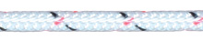
Jib Halyard, 5mm, Twisted Polyester Core-Polyester Cover
White with black and red fleck, 702kg Break Load
48 feet, whipped each end, (reg $31.04) SALE: $20.75

Tack Line, 5mm Vectran, 12strand, no cover
Natural Color, 2405kg Break Load
17 feet, whipped each end, (reg. $25.00) SALE: $16.00
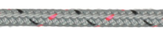
Jib Sheet, 8mm, Excel Fusion, Dyneema SK78 core, blended
Dyneema & polypropylene cover, grey in color, 1411kg Break Load
Cut to order, (reg. $2.14 foot) SALE: $1.82 foot

Tow Line, 8mm, Polypropylene tight weave, yellow in color
66 feet, whipped each end, (reg. $32.45) SALE: $23.50

Marlow Gemini, 9mm, Dual/Twin Dyneema Core, blended
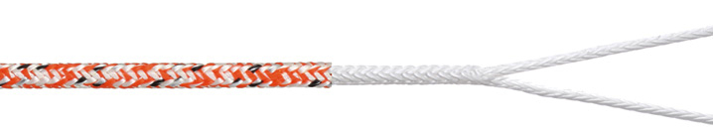
Dyneema & polypropylene cover, orange color, 1434kg Break Load
Limited quantity available (reg. $3.09 foot) SALE: $2.45 foot

OTHER SPECIALS
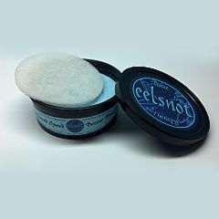
Eelsnot Speed Coating, Eelsnot Boat Therapy is an eco-friendly hydrophobic compound that shields surfaces from direct contact with water. Eelsnot Boat Therapy retards marine growth on hulls at the molecular level. You will go faster
20oz tub, can cover Viper bottom 3x, (reg. $44.99) SALE: $32.75
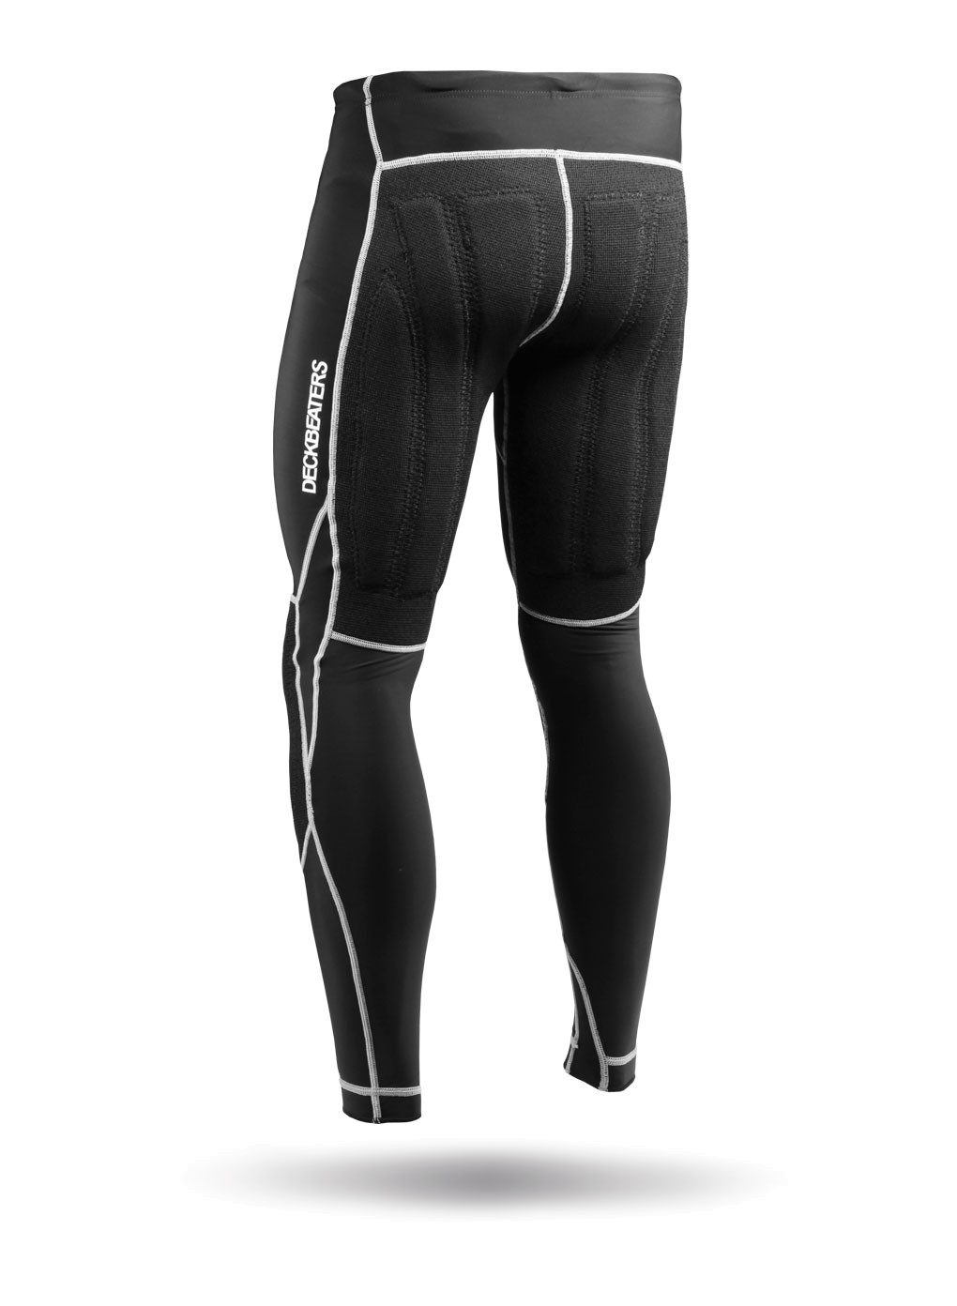
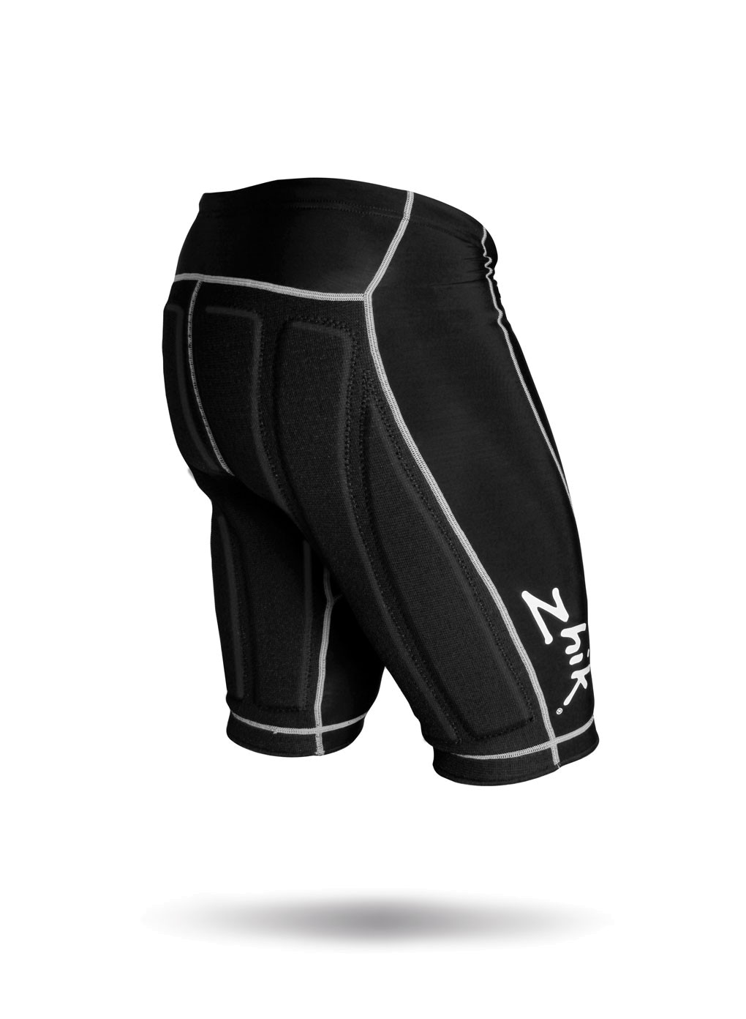
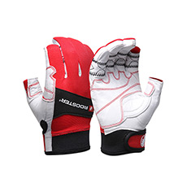

Rooster Sailing Gloves, ¾ finger, and full finger,
3xs,2xs,xs,s,m,l,xl,2xl (reg. $28.89) SALE: $23.69
Zhik Deckbeater Shorts (reg. $115.00) SALE: $92.00
Zhik Deckbeater Pants (reg. $169.00) SALE: $135.00
XS,S,M,L,XL,2XL limited quantities available

15% off Harken Blocks and Cleats, 10% off Ronstan Spin Halyard Swivel Cleat (reg. $56.21)
CALL IN ORDER TO 850-797-2933 or email to contact@gulfperformancesailing.com

