
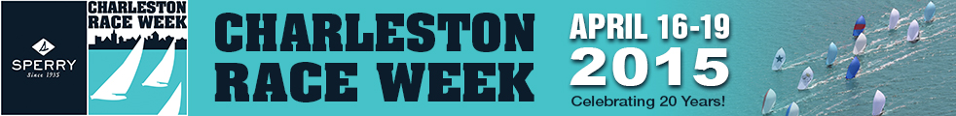

VIPER 640 CRW Update #1
March 23, 2015

Hello, Viper Sailors heading to beautiful Charleston, SC next month. As with any major regatta, there are many moving pieces that owners and crew must contend with to make it an enjoyable event. I’ve don the past three CRWs and am sending along some information for your consideration. I know many of you have been there and done that, but there are some new CRW competitors...so here goes:

Accommodations
Charleston Harbor Resort & Marina (CHRM)
I just called CHRM and there are still room available for CRW if you’ve not gotten that detail taken care of. If you have any questions about reservations please contact the resort by phone at 843-284-7050.

Dock space for the Viper fleet
I have arranged with CHRM for the Vipers to have two U-shaped bays in their marina (four slips as it were) for four days (Thursday – Sunday departure). The price is fixed and when we get confirmation on how many boats will be nesting into these two bays we will divide the cost evenly. All dockage fees MUST be pre-paid by each boat to the yet-to-be-drafted Viper Class representative on site. Please confirm via reply e-mail if you plan on docking in the Viper bays or not. Depending upon the final number of boats and if we’re put on 50’ or 60’ slips the actual cost-per-boat will vary. However, the worst case scenario at this time would be approximately $175 per boat for Thursday – Sunday. Please plan on bringing that much cash the first day to facilitate the required up-front payment.

Docking in the CHRM is not always ideal. The bays/slips are set-up for larger boats and don’t have adequate mid-dock cleats. Also, they are cement docks and boats will be rafting two deep. It’s highly advised you bring lots of fenders and extra dock lines.

Lunches delivered to the dock – a nice touch! Honey Baked Sandwich Company
There is a great sandwich place in Mt. Pleasant that we stumbled across four years ago and now they deliver lunches right to the head of the dock at the CHRM. You can order all your lunches at the same time and they will be there for you every morning. It’s plug and play. Some cautions: Honey Baked sends you boxed lunches. You’ll want to take them out of the boxes and transfer them to dry bags leaving the boxes ashore. Also, I seem to remember the sandwiches weren’t cut in half so I did that before taking them to the boat. BTW, they have great chocolate chip cookies.

Launching/hoisting:
Two real options: the Remley’s Point boat ramp in Pt. Pleasant and the Charleston Yacht Club. Details at http://www.charlestonraceweek.com/storage-launch-haul.html. The boat ramp is a bit closer to CHRM but it doesn’t have any facilities. At the SCYC, you can pay up-front to launch and haul at the end. Some considerations:
- If you’re going to the boat ramp, take an adequate supply of bug spray.
- When hauling at the SCYC, recognize that there will be a lot of J/24s, Melges and J/Boats also launching and hauling at the same time. You may have a bit of a wait to get out. However, the gas station at the entrance to the club parking lot sells beer and soda so you can stay well hydrated while you’re waiting for the hoist.
  - CHYC launching times are Thursday from 1000 to 1800 hrs, and Sunday after racing until done. Approx. 4 miles from Race Village. Contact: John Gagg 843-207-1222 or Brian Swan 843-209-7286 for details.
  - Important safety tip: There is a woman who “manages” the order of hauling out at CHYC. She has a tough job keeping track of who arrives when as boats come in. Some boats “stage” themselves across the water from the club’s docks. Last year the boats on the club side (regardless of when they arrived from the final race) were hauled first. Think club side when you enter the basin.

Trailer parking:
Whether you launch at the club or the ramp, you’ll need to park your empty trailer in the field just to the north of the bridge in Pt. Pleasant. Trailers will need to be stored at the Mt. Pleasant Recreational Pier Park, underneath the Ravenal Bridge. Locking your trailer is advised. The blue indicator below is the trailer parking field.

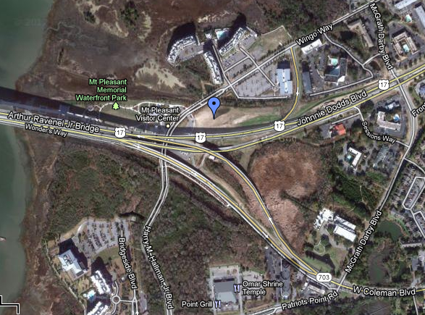

Two great restaurants to try
I have some good friends with a home in Charleston and they are both foodies. They have taken us to Perlz (153 E Bay St, Charleston) which has great oysters and local food. Casual and lots of fun. The other place is The Wreck (106 Haddrell Street, Mount Pleasant). This hard-to find place (trust your GPS on this one...and look for the actual wreck in the trees to the right behind a boat yard...that’s the “sign”). Really casual, on the river so bring your bug spray, and welcome the cool beers on the dock overlooking the river’s fishing fleet as you wait for your table. Think Forest Gump Shrimp Company. (BTW, great fried green tomatoes.)

Got any other suggestions? Let me know and I’ll share them with the rest of the Viper sailors going to the low country next month.

More to come,

Buttons

