
Sailing Instructions
TransLoch Race
January 17, 2015, Lake Pleasant, Arizona

The TransLoch Cruising Race shall be limited to boats that are fully equipped to Cruise. The boats shall include a full interior with a galley and a head, a minimum of two anchors, Dacron or nylon sails only and an operational motor. Finish order will be determined using Southern CA PHRF handicap. Handicap adjustments will be allowed as follows: Towing a dinghy: 10; cooking on BBQ: 6; children under 6 years of age: 2 each; each pet over 10 lbs.: 2 each. Sailing instructions and advice will be available on VHF Chanel 68
Starts will be broadcast on VHF with a countdown.
The START on Saturday will be 30 minutes PRIOR to the general ‘late’ racing start (10:30 am). The course for this fleet is as follows:

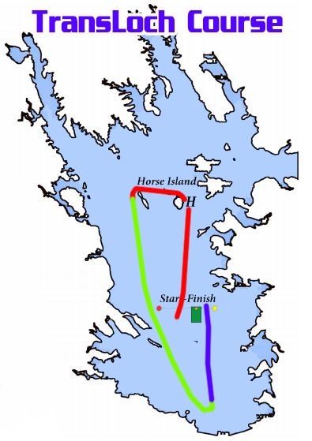The TransLoch Cruising course shall be from the start line, around the north side of Horse Island, then around the north side of Balance Rock, then around the south side of the small unnamed island (with permanent vegetation) at the south end of Lake Pleasant near the dam overlook visitors center (33*51.07 N, 112*16.57 W), and then to the finish line. Round all marks to Port.

STARTING SEQUENCE:
5 - MINUTES – Fleet mark displayed

4 - MINUTES - FLAG GOES UP

1 - MINUTE -FLAG COMES DOWN
0 - START!

NOTE:
- All boats must check in by sailing aft of the
Race Committee on starboard tack and
hailing FLEET, SAIL NUMBER and SKIPPER’S
name before the race.
- A boat that retires from a race or retires from
racing before the end of the race day
shall notify the Race Committee as soon
as possible.
-VHF RADIO – Channel 68 and 71

SKIPPER’S MEETINGS: (IMPORTANT) Will be held in the vicinity of the AYC Hospitality
Ramada on “Lookout Point” overlooking Pleasant Harbor Marina. Saturday 1/17/2015 9:00 am
FLEET IDENTIFIER: All boats in the TL Fleet are asked to fly a streamer of any length or color off the backstay.
CRUISING FLEET CAPTAIN: Tom Errickson
SIGN UP: http://arizonayachtclub.org/ayc-bdr/
ADDITIONAL INFORMATION: Available at: http://arizonayachtclub.org/

