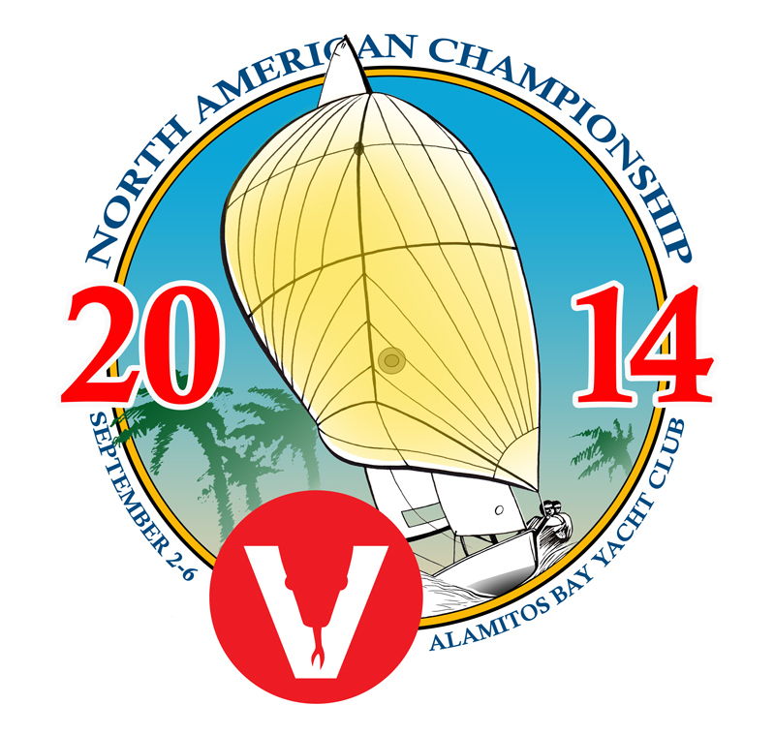

2014 Viper North American Housing Links
- Ayres Hotel Seal Beach
The $119.00 discounted rate at the Ayres Hotel Seal Beach includes a full breakfast, complimentary parking and Internet
Enterprise Rent-a-car office at the hotel
Ayres is located 5 miles (10 minutes) from ABYC
https://booking.ihotelier.com/istay/istay.jsp?HotelID=12622&rateplanid=1441891

- HMS Queen Mary (yes, her majesty’s ship)
Alamitos Bay Yacht Club- Queen Mary Reservations
http://www.youtube.com/watch?v=FW5ftnoRTYs&feature=youtu.be

- VRBO (Vacation Rentals By Owner)
http://www.vrbo.com/

- AIRBNB
https://www.airbnb.com/

- Limited amount of housing in Club members homes. Targeting the furthest travelers.
Contact Tim Carter

